***1.What is Framework?***

It is collection of reusable components which makes automation script development execution, maintenance and modification is easier and faster.

***2.Which Framework Approach?***

TDD (Test Driven Development)

***3.What type of Framework?***

Hybrid Driven Development

***4.Components used in your Framework?***

* Jenkins
* POM.XML
* Commondata Properties
* TestData
* Generic Utilities
* POM Pages
* TestScripts
* Suite.XML
* Reports

***5.Framework Architecture*:**

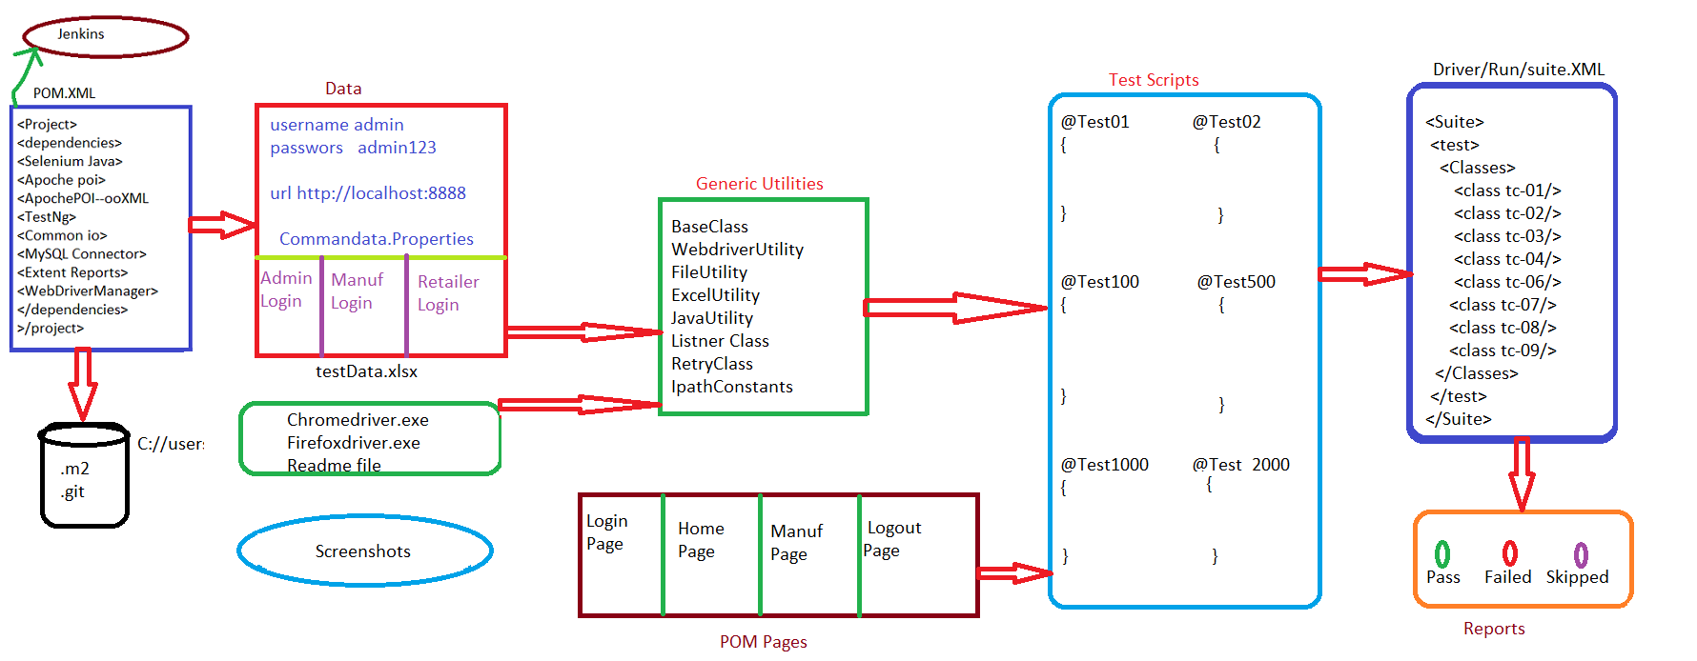

The above image shows the architecture of the Framework, which consists of many dependencies and Components.

The dependencies used in Framework are:

* Selenium -- 3.141.59
* MySQL-connector -- 8.0.28
* Apache poi -- 4.1.2
* Apache poi- ooxml -- 4.1.2
* Webdrivermanager -- 5.3.2
* commons-io -- 2.11.0
* testing -- 7.4.0
* extent reports -- 5.0.9

Components:

1.Jenkins: Jenkins can schedule our tests to run at specific time. We can save the execution history and Test Reports.

**2.POM.XML:** The pom.xml file contains information of project and configuration information for the maven to build the project such as dependencies, build directory, source directory, test source directory, plugin etc.

**3.Commondata Properties:** As per the rule of Automation data should not be hardcoded within Test Script, so we have to store the data in property file because it is lightweight and faster. And the common data includes username, password, Browser and Application URL which are common to all the Test Scripts.

**4.TestData:** We used Apache Poi library to store the data in Excel. Apache Poi is open-source library which helps to read and write the data in to Microsoft Excel.

The data present in the Test data is used for particular Test Scripts.

**5.Generic Utilities:** We categorised the Utilities based on the contents.

* WebdriverUtility which consists all the actions with respect to driver.
* In FileUtility we load all the data from Commondata property file.
* ExcelUtility consists of methods to read and write the data into excel.
* In JavaUtility, here we create a method for Random number and for Date format.
* IpathConstants consists all the paths like dbURL, dbpath, Filepath and ExcelPath.
* BaseClass:

It consist of selenium configuration annotations used to perform actions like Connecting to DB, Launch the Browser, Login to application, Logout from the application and Close the DB connection.

* Listener Class: We have implemented ITestListener to take the screenshot for the failed test scripts.
* IRetryAnalyser : We have implemented IRetryAnalyser to rerun the failed test Scripts, which are got failed due to the reason of server issue or network issue.

**6.POM Pages:** Pom is well organized java design pattern where we can store WebElements. In Framework we have created POM classes for each Web Pages.It can handle StaleElementReferenceException.

**7.TestScripts:** Test Scripts are step-by-step instructions on how to test a test case. They are detailed and contain individual steps that test for each and every functionality. Test scripts are programs that execute tests on the software product/application.

**8.Suite.XML:** Here we can do different kinds of Executions like Batch Execution, Group Execution, Distribute Parallel Execution and Cross Browser Execution.

**9.Reports:** Extent Reports is implemented in ItestListener which is used to generate the reports of failed, passed and skipped Test Scripts and It will take the ScreenShot of failed Testscript.

***7) Exceptions you have encountered in our framework?***

* No such-Element Exception: If element is unable to find due to wrong X-path or synchronization problem so to overcome from this x-path need to be rectified or give proper wait statement as per the application behaviour.
* No such window Exception: While trying from switching one window to another window there will be an exception due to synchronization or wrong window address so first need to check the proper window address or add proper wait statement.
* No such frame Exception: While trying from switching from window to frame there will be an exception due to synchronization or wrong frame address so first need to check the proper frame address or add proper wait statement.
* No such alert present Exception: While trying from switching window to alert there will be an exception due to synchronization so need to add proper wait statement.
* Web-Driver Exception: When web-Driver is unable to launch the browser due to low speed of data and that cab be handled by speeding up data
* Testng Exception: If there is cyclic dependency between methods or disable the depends on method that time we will get this exception to overcome from this need to remove depends on method.
* Method Matcher Exception: When we there is a mismatch between rows from data provider and the parameters which we are utilizing then we get this exception to overcome from this both side parameters length should be same.
* Assertion Error Exception: Whenever assertion method fails in a test script.

***Advantages of Framework:***

* Saves time and effort in testing.
* The fastest way to test applications.
* Scaling and maintenance are easy.
* Allows easy execution of multiple datasets.
* Avoids hard-coded data.
* Allows building test scripts independently of the platform and applications under test.
* Helps in writing lightweight and easy-to-understand test scripts.
* High code reusability.